**Personal Portfolio**

Group 73

William Huggett – N9739769

https://github.com/jakuv/seventy-three

**Artefact 1** – (Sprint & Release burn-down charts (diagram))

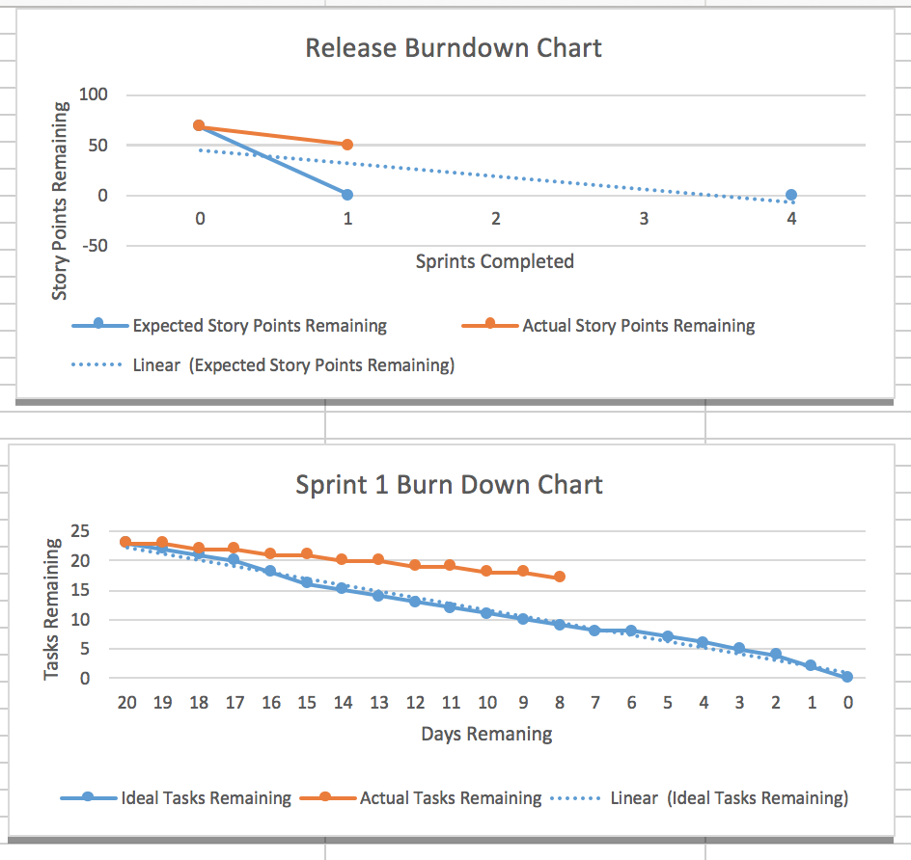

The release burndown chart shows the projects progress for each release. This contributes greatly to the project as the team can gauge how much work has been done and how much needs to be done to deliver the project on time. The sprint burndown chart is similar. It graphs the ideal number of tasks remaining against the actual number of tasks remaining. This helps a great deal because it shows the amount of work that needs to be done to complete the sprint on time.

[**seventy-three**](https://github.com/jakuv/seventy-three)/**Sprint & Release burndown charts.png**

Relevant story from sprint – Not applicable

**Artefact 2** – (Test code with comments (code))

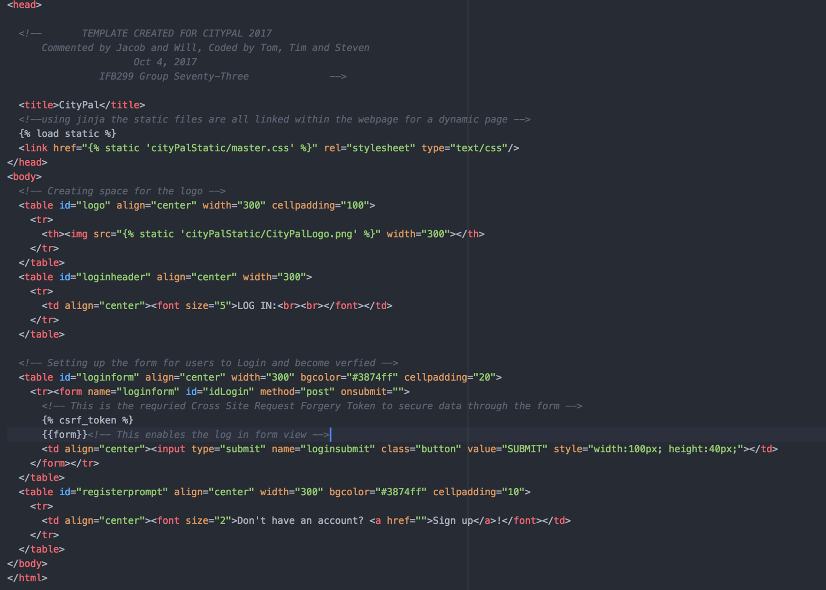

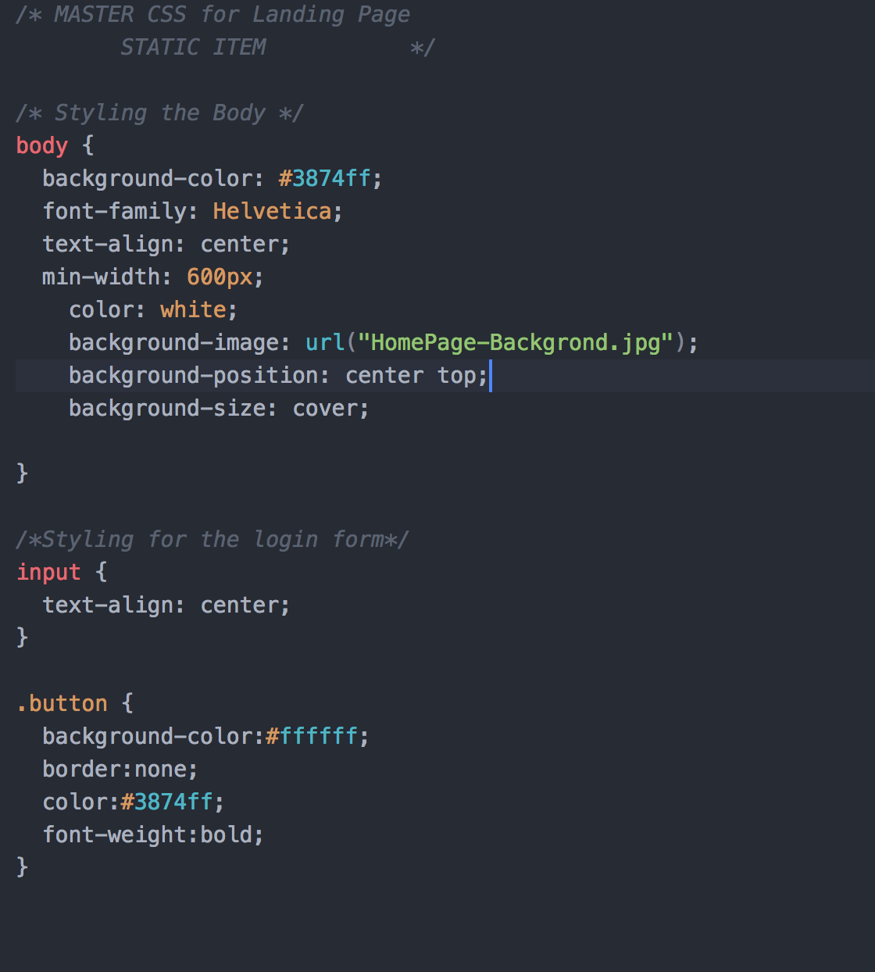

The code was produced from the development team (CS students) and the comments were done afterwards by the clients (IS students). Together this has contributed greatly to the project. This is because this is the code for the creation of the website’s login page using Python and CSS. There’s also code that allows the user to log in and out of the website.

[**seventy-three**](https://github.com/jakuv/seventy-three)/**IFB299 2:3.png**

[**seventy-three**](https://github.com/jakuv/seventy-three)/**IFB299 1:3.png**

Relevant story from sprint – S01, S02, S04

**Artefact 3** – (High fidelity UI design of login page (other))

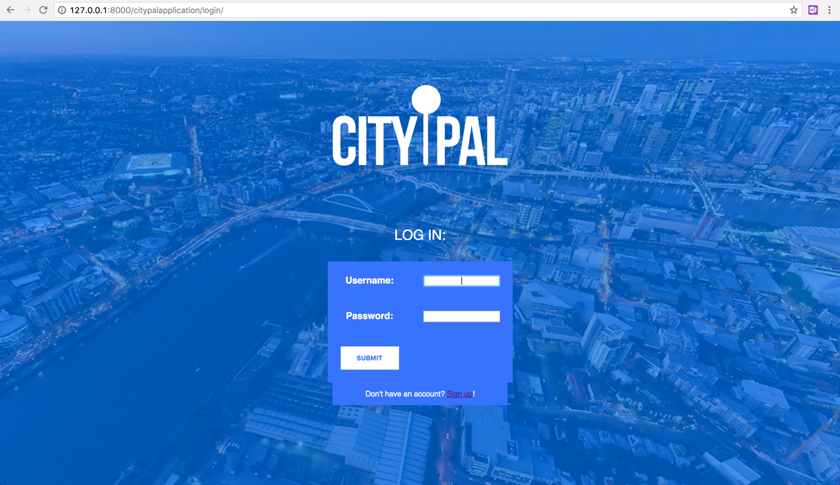

This is the user interface of the website’s login page. It is a great contribution to the project as it is the first page the user will experience. It was designed by the IS students and constructed with Python and CSS by the CS students. It was made to be user-friendly, a simple design with Brisbane City as the background and fields for the username and password for the user to login and has the option to sign up which is very important.

[**seventy-three**](https://github.com/jakuv/seventy-three)/**CityPal Login.png**

Relevant story from sprint – S01, S02, S04

**Artefact 4** – (Use case diagram for website (diagram))

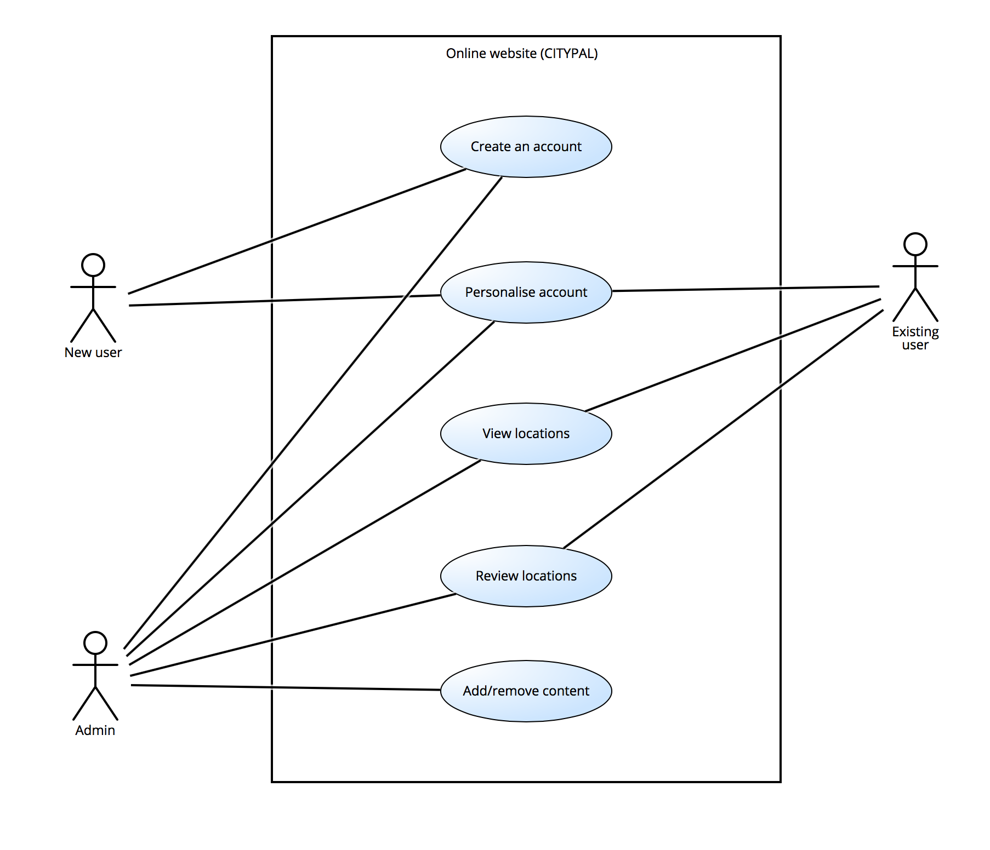

This is a use case diagram for our online website CityPal. This diagram clearly shows how different users will be able to interact with different features on the website. For example, a new user can only create and personalise an account. Once they’re an existing user they can view and review locations. As for admins, they have access to every feature. This representation helps give a better understanding of how the website will be used.

[**seventy-three**](https://github.com/jakuv/seventy-three)/**Use case of website.png**

Relevant story from sprint – S02, S07, S08, S10

**Artefact 5** – (N-tier software application architecture (diagram))

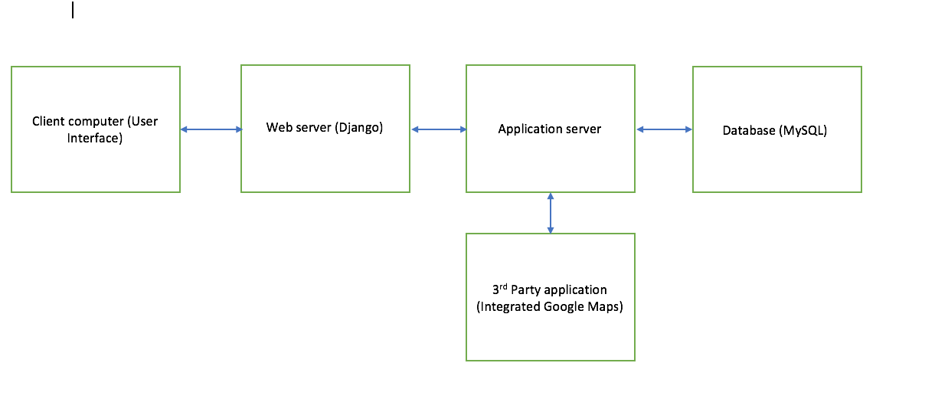

This N-tier software application architecture was used to gain an understanding of how the website will operate. This is very important because it allowed the group to understand that the client’s computer will interact with our website through the user interface therefore we needed to make it user-friendly. It also shows that our web server is hosted through Django which informs our development team they need a thorough understanding of how that works. The applications are made from Python code and are available through the web server. The application server is connected to a MySQL database which allows the storage of the user’s and city information. The application server will also have integrated Google Maps and possibly Uber services which are both 3rd party applications.

[**seventy-three**](https://github.com/jakuv/seventy-three)/**N-tier architecture.png**

Relevant story from sprint – Not applicable

**Artefact 6** – (Client requirements (other))

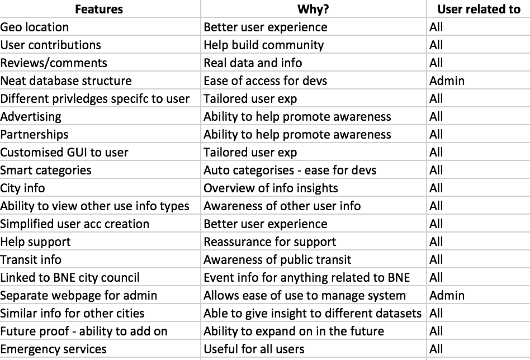

This is an analysis of the initial needs and wants of the client and was produced primarily by the IS students of the group. This is a significant contribution to the project because it highlights the key features that the website should have and why. It also informs the development team to what they need to be working on. This analysis was used to generate the user stories which then lead to the sprint and release plans.

[**seventy-three**](https://github.com/jakuv/seventy-three)/**Client requirements.xlsx**

Relevant story from sprint – S01-S20